Development Specifications Document (DSD)

*Process Name: Send_confirmation*

Table of Contents

I. Document Overview 1

II. Automated Master Project Details 1

III. Runtime Guide 2

1. Runtime Diagram 2

2. List of Packages 2

3. Master Project Runtime Details 3

IV. Project Details 4

1. Project Name: Send_confirmation 4

1.1 Workflow(s) specific to the Project 5

V. Compliance Considerations and Reporting Requirements 6

VI. Other Details 7

1. Future Improvements 7

2. Debugging Tips 7

3. Other Remarks 7

VII. Post UAT Specifications 7

VIII. Glossary 7

Version Control

|  |  |  |  |  |  |  |
| --- | --- | --- | --- | --- | --- | --- |
| Date | Version | Role | Name | Organization Department | Function | Comments |
| 2021-05-08 | 1.0.1 | Author | Kamal | Finance | Analyst/ Developer |  |

# Document Overview

The Development Specifications Document (DSD) is created for every business process automated using RPA. The DSD needs to be reviewed and updated for every change requested and applied to the automated process. This document provides a technical snapshot and must always reflect the latest design and key features of the automated workflow.

The document naming convention will follow the naming convention and the version of the automated process. This can be “business process name version” or it can be defined, case by case, as part of the larger RPA project design.

This document is completed by the RPA Solution architect and RPA developer who automates the business process. It is reviewed by the business process owner, application owner, and CoE design authority.

This document is meant to assist the RPA COE, IT operations and process owners by providing a snapshot of the automated process details and components. It can also serve developers to have a quick glance at the setup, before diving into the code, to troubleshoot or update changes. The purpose of the document is to record the outcome specific to the automated master project and its subcomponents: projects, workflows, sequences etc.

# Automated Master Project Details

Details filled in by the developer reflect the actual information for the master project released for production.

|  |  |  |
| --- | --- | --- |
| # | Item | Details  Fill in with free text. If not applicable, mark the filed as "N/A". No empty fields. |
| 1 | Master Project Name and Version | Send_confirmation , 1.01 |
| 2 | Robot Type (attended/unattended/mix) | Unattended |
| 3 | Is Orchestrator used? (Yes/No) | Yes |
| 4 | Scalable? (Yes/No)  Can the process be run by multiple robots in parallel? | Yes |

# Runtime Guide

## Runtime Diagram

**Architectural Structure of the Master Project** Display the interaction between components (package / robots, Orchestrator queues, and running order).

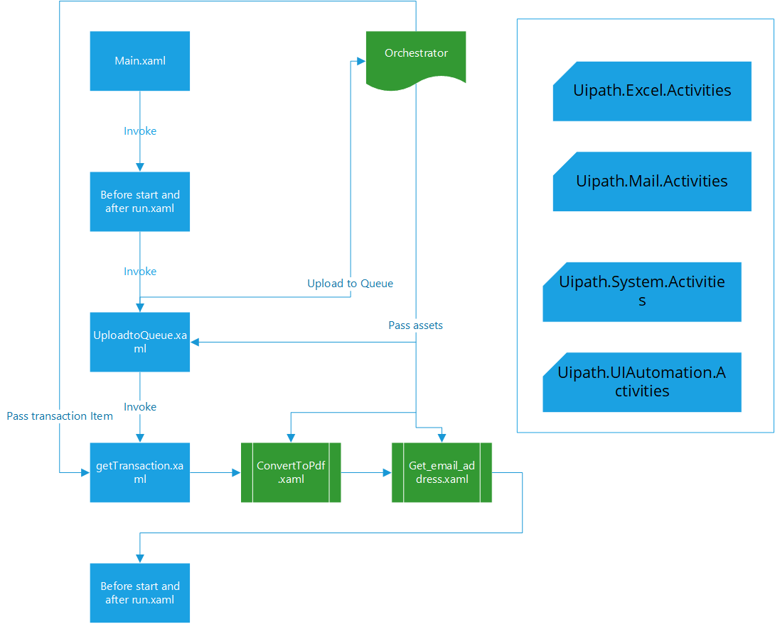

## List of Packages

Include **the list of packages and the high-level description** for each of them, to explain each one's purpose:

|  |  |  |
| --- | --- | --- |
| # | Package Name | High-Level Description |
| 1 | Send_confirmation | User go to a folder in hard drive, look for folder with current date, for each of the excel files name matching “date-caseid-amount” example 20210316-xyz123-300.xlsx; open the file, convert the “customer copy” worksheet to pdf, pick up the customer email from the file and send out the email using outlook with pdf as an attachment. Repeat the steps for all the files processed today. |

*Add more rows to the table to include all the project names and versions. No fields should be left empty. Use “N/A” for the items that don't apply to your project.

## Master Project Runtime Details

Details of the automated process:

|  |  |  |
| --- | --- | --- |
| # | Item | Details  (Fill in with free text. If the section does not apply to your automation, mark the field as “N/A”. No empty fields. ) |
| 1 | Production Environment Details | MANDYS-MSN, C:\Users\mande\Documents\UiPath\Send_confirmation, Windows 10 |
| 2 | Prerequisites to run | Install Microsoft Excel 2016, Microsoft Outlook 2016 |
| 3 | Input Data | Structured, Example input file: 20210316-xyz123-200.xlsx |
| 4 | Expected Output (output data) | Converted Pdf files and sent outlook emails |
| 5 | How to start the automated process? | User can initiate the process by running the Main workflow |
| 6 | Resuming the process from a particular step | N/A |
| 7 | Reporting  queues reporting, Kibana or another platform | N/A |
| 8 | Manual Error Handling  roll back or manually complete failed transactions. Procedures to reset the item. Ex “set status as investigating” | N/A |
| 1. How to resume the process in case of error | Only anticipated Business exception “files not found”, restart the process if needed. |
| 1. How to manually fix transactions with error | N/A |
| 9 | Use of Orchestrator |  |
| 1. Password Policies   specific compliance requests? | No Passwords required |
| 1. Stored Credentials   Never hard code credentials in the workflow | N/A |
| 1. List of Asset Names | Sharedrive_Path, Process_owner_email |
| 1. List of Queues Name | file_Processing |
| 1. Schedule Details | Send_confirmation_Trigger (1 pm) |
| 10 | Recommended Resolution | N/A |

# Project Details

In this section describe all the projects that compose the automated process.

For each project, describe the workflow(s) in the logical order that they are called in.

If the workflow is a flowchart, also include the exported image from Studio.

If the automated process is composed of multiple projects, copy paste and fill in the table below for each project with its specific details (there are 2 here already, assuming a dispatcher and performer project)

## Project Name: Send_confirmation

General information about the process selected for RPA prior to automation.

|  |  |  |
| --- | --- | --- |
| # | Item Name | Details  Fill in with free text. If not applicable, mark the field as “N/A". No empty fields. |
| 1 | Environment used for development  name, location, configuration details etc | MANDYS-MSN, C:\Users\mande\Documents\UiPath\Send_confirmation, Windows 10 |
| 2 | Environment prerequisites  OS details, libraries, required apps | Microsoft Windows 10, Microsoft excel 2016, Microsoft outlook 2016 |
| 3 | Logging level | info |
| 4 | Details about automation  if the apps were automated using UI Automation, Image & Text | Ui Automation |
| 5 | In case of attended bot, can the user operate the computer while the robot is running? | No |
| 6 | Repository for project  where the developed project is stored | https://github.com/iamkamal-cheema/Send_confirmation |
| 7 | List of reused components | NA |
| 8 | Custom logs defined in the workflows  where Throw Activity was used or custom log message was defined | (Yes) |
| 9 | Frequent errors found in the development phase | NA |
| 10 | Workarounds used in the automation phase | Before start and after run.xaml workflow used to have the apps ready in the desired state |
| 11 | Configuration method  assets, excel file, Json file | Json file |
| 12 | Configuration details  path for input files, configuration Orchestrator assets used | Orchestrator Asset: Sharedrive_Path Value: C:\Users\mande\Documents\UiPath\Send_confirmation\Capstone project\content  Orchestrator Asset: Process_owner_email Value: kamal.cheema53@gmail.com Orchestrator Queue: file_Processing |
| 13 | Workflow File Export List  Use the project mapping tool | NA |

### Workflow(s) specific to the Project

Define below all the workflow files (.xaml files) used in the project, with the Input and Output data.

|  |  |  |  |  |
| --- | --- | --- | --- | --- |
| **#** | **Workflow Name** | **Description** | **Arguments** | **Comments** |
| 1 | Main | Main workflow used to trigger other workflows in the capstone RPA project. 1.Bot look up a path on hard drisk, look for a folder named as current date (YYYYMMDD)  2. Loop through excel files matching a particluar name pattern.  -convert one of the worksheet " customer copy" in the excel file to pdf.  -Pick email address from another excel worksheet "main file" to send out emails with pdf as attachment. | NA | NA |
| 2 | UploadtoQueue | Workflow to navigate to folder matching current date (today) and get the files matching the criteria. Upload the full file path including file name to Orchestrator queue. | NA | Orchestrator Queue: file_Processing |

|  |  |  |  |  |
| --- | --- | --- | --- | --- |
| 3 | Before start and after run | This workflow is used to Shut down applications; outlook and excel, before the main automation begins , to avoid opening mutiple instances of an appliaction. The workflow is also used at the end of the automation to close applications involved. | NA | NA |
| 4 | getTransaction | Get items from the orchestrator Queue and then invoke convertTodf and get_email_address workflows. | NA | NA |
| 5 | ConvertToPdf | Workflow converts the excel worksheet to pdf | in_FileName in_CurrentDate in_PdfFileName | NA |
| 6 | get_email_address | Sends out the email wth pdf file as a attachment. | in_FileNameEmail in_CurrentDate in_PdfFileName | NA |

# Compliance Considerations and Reporting Requirements

* AS the process is automated, compliance confidence is high for the automated operator, Quality control team can do spot checks to see bot’s performance and logs will be available in orchestrator for further exploration.

# Other Details

## Future Improvements

* End of run report for Business owner, metrices like number of emails sent, time taken to complete the process.

## Debugging Tips

* Traditional debugging options available in the studio, debug workflows independently.
* During debug, activity which is being debugged remains highlighted when paused. Debug actions like Step Into or press Stop to exit and return to design mode.

## Other Remarks

* Having Microsoft excel start in the desired state is the key , otherwise you may have multiple instances of it running , included the workflow Before start and after run.xaml to deal with the issue.

# Post UAT Specifications

* Average duration per transaction (varies depending on the Test environment):
  + 1 minute/ transaction
* Recommended number of robots for the specified volumes: 1
* Specified schedule: 1 Pm

# Glossary

* **Master project** - the overall output of the development, containing one or multiple projects that together cover the scope of the robotic process automation.
* **Project** - a UiPath Studio project containing one or multiple workflow files. A project can be converted to a package and run independently, covering a particular scope within the master project. The project is used when defining the development and support phase of the automation.
* **Package** - the output of compiling a project. A package can be deployed on the robot machine and be executed by the robot service. Only one package can be executed at a given time by a robot. The package is used when defining the running phase of the automation
* **Workflow** - a component of the package, the workflow encapsulates a part of the project logic. The workflow can be of type: sequence, flowchart or state machine. a workflow is saved as an .xaml file inside the project folder. A workflow file can be invoked from another workflow and by default there is an initial workflow file that will run when executing the package.
* **Activity** - an action that the robot executes.
* **Sequence** - a workflow where activities are executed one after another, in a sequential order
* **Flowchart** - a workflow where activities are connected by arrows and the logic of the workflow can be easily followed in a visual manner. The flowchart can also be exported as an image from UiPath studio
* **State machine** - a more advanced way of organizing a workflow, similar to a flowchart.
* **BOR** - Back office robot
* **FOR** – Front office robot
* **Orchestrator** – Enterprise architecture server platform supporting: release management, centralized logging, reporting, auditing and monitoring tools, remote control, centralized scheduling, queue/robot workload management, assets management.